CAPEX Flow
Standard Operating Procedure
United Uptime Services • Capital-Expenditure Request Workflow

Purpose: Submit, route, approve, and complete CAPEX requests. Audience: Requestors, Approvers, Finance, Administrators. Updated: 2026-07-09

1. Overview
CAPEX Flow is an internal web app that takes a capital-expenditure request from draft, through multi-level approval, to finance completion. The number of approval levels a request must clear is decided automatically by its total cost. Each approval level has a pool of eligible approvers, and any one member of the pool can act on the request.
Access (dev): http://localhost:5000 • Dev admin login: admin / ChangeMe123!

2. Roles
A single user may hold more than one role.
Role | Can do
REQUESTOR | Create a draft, complete the 6-step wizard, submit, and resubmit their own rejected requests.
APPROVER | Approve or reject requests at a level whose approver pool they belong to.
FINANCE | After a request is fully approved, complete the finance cost breakdown. Can view all requests.
ADMIN | Manage users, divisions, and approval thresholds. Can view all requests.
Delegate (out-of-office): Every user may name a delegate. When an approver has a delegate set, the system routes their approvals to the delegate instead, and the audit trail records that the delegate acted for the original approver.

3. The request lifecycle
A request moves through the states below. Only the approval levels the total cost requires are used. REJECTED is a side state: the requestor (and only the requestor) may edit and resubmit, which sends the request back to the start.
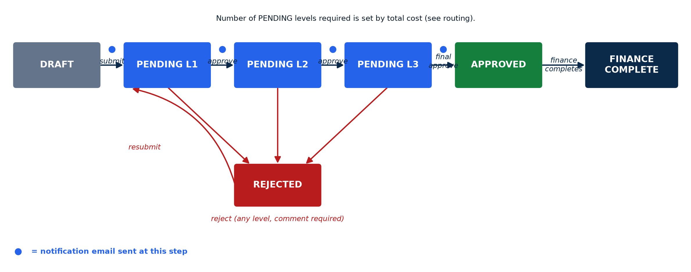
Figure 1 — Request lifecycle and the points where notification emails are sent.
A request is editable only while in DRAFT or REJECTED status. Once submitted, requestors cannot change it.

4. How the number of approval levels is decided
When a request is submitted, the app sums the cost of all equipment line items into the total cost, then compares it against the approval thresholds. The required level is the lowest level whose cap is at or above the total cost; the top level has no cap and catches everything above it.
Level | Max amount (default) | Applies to
L1 | $50,000 | Requests up to $50k — 1 level of approval.
L2 | $250,000 | $50,001 – $250,000 — 2 levels.
L3 | (no cap) | Above $250,000 — 3 levels.
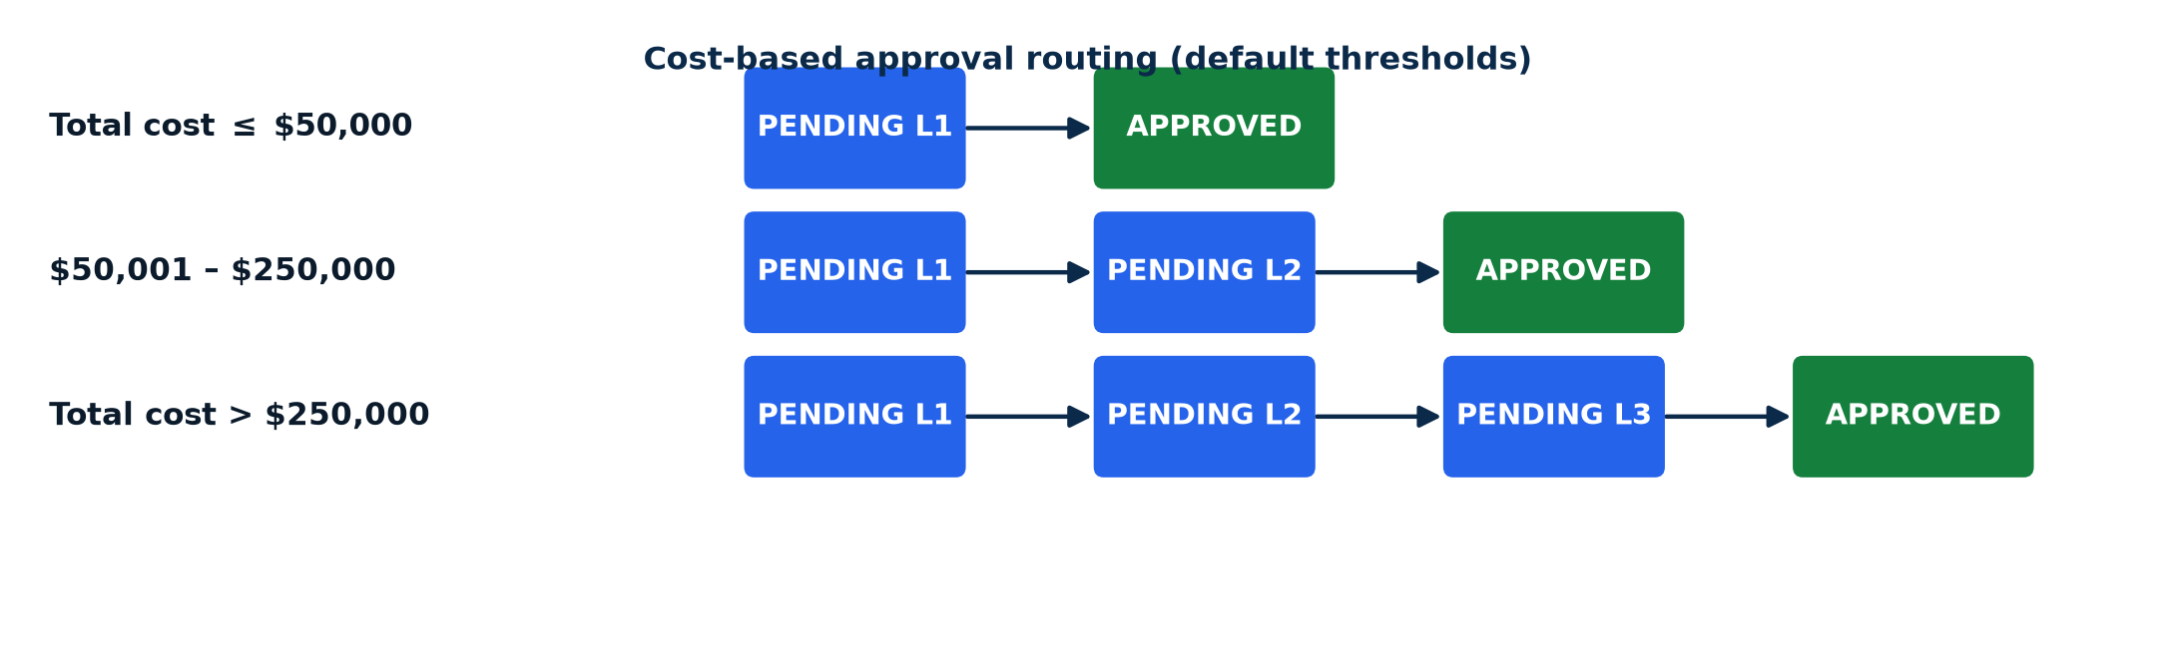
Figure 2 — Cost-based approval routing using the default thresholds.
Thresholds are configurable by an Admin under Admin → Approval Thresholds. Changing the caps changes how future submissions are routed.

5. Who approves at each level
Each level draws its eligible approvers from a different place:
- Level 1 — the division's L1 approver pool (set under Admin → Divisions).
- Levels 2 and 3 — the threshold's approver pool (set under Admin → Approval Thresholds).
Each configured approver is mapped through their delegate (if any) to produce the people who may actually act. Any one of them can approve (which advances the request) or reject. The request appears on the “Assigned to me” worklist of every eligible approver at the current level; only the first action counts — a second action on an already-decided request is rejected.

6. Step-by-step procedures

6.1 Requestor — create and submit
- Click New Request — this creates a draft and opens the 6-step wizard.
- Complete the steps: Basic Info → Description → Effect on Operations → Equipment → Economic → Review.
- Add at least one equipment line item with a cost greater than 0 (its sum drives routing).
- On the Review step, click Submit. The request moves to PENDING L1 and the L1 pool is notified.
Submit prerequisites: at least one equipment line item with a positive cost; a division set on the request; and the division has at least one L1 approver configured.

6.2 Approver — approve or reject
- Open a request from “Assigned to me” or the dashboard approvals table.
- Approve (optional comment) — advances to the next required level, or becomes APPROVED if this was the last level.
- Reject (comment required) — moves to REJECTED and notifies the requestor.

6.3 Requestor — resubmit a rejected request
- Open the rejected request (it is editable again).
- Fix what the rejection comment called out.
- Click Resubmit — routing is recomputed and the request re-enters PENDING L1.

6.4 Finance — complete the cost breakdown
- After a request is APPROVED, all Finance users are notified it is pending.
- Open the request and fill in the breakdown: autos/trucks, machinery, improvements, furniture, permits, misc.
- Click Complete — this can be done once, only by a Finance user, only on an APPROVED request.

7. The notification / email process

7.1 When notifications fire
Event | Who is notified | Type
Submit (→ PENDING L1) | Every eligible approver in the L1 pool | ASSIGNED
Approve, not final (→ next level) | Every eligible approver in the next level's pool | ASSIGNED
Approve, final (→ APPROVED) | The requestor | DECIDED
Approve, final (→ APPROVED) | All active Finance users | FINANCE_READY
Reject (→ REJECTED) | The requestor | DECIDED
Resubmit (→ PENDING L1) | Every eligible approver in the L1 pool | ASSIGNED
Recipients are always resolved through the delegate mapping. Notifications are best-effort: a delivery failure is logged and never blocks or rolls back the workflow transition.
Email content: each body includes the request details (requestor, division, total cost) and a deep link straight to the request in the app — the approver clicks it and lands on the request detail page where the Approve / Reject buttons are. There is no approve-from-email; the link takes them into the app to act. The link is built from the APP_BASE_URL config, so set that to the real hostname on the server. Example approver email:
Subject: Action needed: CX000042 awaiting your Level 2 of 3 approval
Request CX000042 needs your Level 2 of 3 approval.
Requested by: Dana Ruiz
Division: 12 — Field Services
Total cost: $182,400.00
Review and approve:
http://localhost:5000/requests/<id>

7.2 How mail is sent today (local Outlook)
For every notification the app always writes a log line and records a row in the NotificationLog table. When EMAIL_ENABLED is on (the default in dev), it also sends the message through the Outlook desktop app installed and signed-in on the machine running the app (via COM automation). No SMTP credentials or Azure app registration are needed — the mail goes out as the signed-in Outlook account.
⚠ Redirected while testing: every message is currently redirected to EMAIL_REDIRECT_TO (default bryan.farrell@uniteduptime.com) instead of the real recipient. The intended recipient is written at the top of the body as “[Intended recipient: …]”. To deliver to real recipients, clear EMAIL_REDIRECT_TO.

Config var | Default (dev) | Meaning
EMAIL_ENABLED | 1 (on) | Set 0 to log/record only and not send.
EMAIL_REDIRECT_TO | bryan.farrell@uniteduptime.com | Where all mail is sent while testing. Clear it to send to real recipients.
APP_BASE_URL | http://localhost:5000 | Base URL for the deep link in every email. Set to the real hostname on the server.
Requirements to actually send: runs on Windows with the Outlook desktop app installed and signed in; pywin32 installed (Windows-only, in requirements.txt).
Moving to a server: the Outlook desktop backend will not work headless. Replace app/services/email_outlook.py with an SMTP or Microsoft Graph backend — that module is the only place delivery lives, so all the routing logic above stays unchanged.

7.3 Editing the emails (Admin → Email Templates)
Admins can customize all four emails without code changes under Admin → Email Templates. For each type you can edit the subject, the body (a WYSIWYG rich-text editor — fonts, sizes, colors, lists, links), and an enabled toggle. A right-hand placeholders panel lists the {tokens} available for that email (e.g. {number}, {requestor}, {division}, {total_cost}, {link}, plus {level} for the approval email and {comment} for the rejection email); click one to insert it at the cursor. Tokens are replaced with real values when the email is sent.
Brand frame & buttons: every email is wrapped in a fixed brand frame (navy header, United Uptime Services / CAPEX Flow) so all four stay on-brand. Save updates the live template; Save as Default captures the current version as your baseline; Preview renders it with sample data; Reset to default reverts to your saved baseline (or the shipped default if none was captured).

8. Administration
Under Admin (ADMIN role required):
- Users — create/edit users, assign roles, set division and out-of-office delegate.
- Divisions — create divisions and set each division's L1 approver pool.
- Approval Thresholds — set the L1/L2/L3 caps and the L2/L3 approver pools.
- Email Templates — customize the subject, body, and enabled state of the four notification emails, with {token} placeholders and a brand frame (see 7.3).
Setup checklist for a working workflow:
- Create divisions and assign each an L1 approver pool.
- Set the threshold caps and the L2/L3 approver pools.
- Create users with the right roles and divisions; set delegates as needed.
- Confirm at least one active Finance user exists.

9. Audit trail
Every action is recorded and shown on the request detail page: SUBMITTED, APPROVED, REJECTED, RESUBMITTED, FINANCE_COMPLETED — each with the level, actor, optional comment, and, for delegated actions, whom the actor acted for. This is the system of record for who did what and when.

